BOOK 02 / CURRENTLY IN PRODUCTION
The Artisan’s Approach™
to Integrative Medicine
A WORKING  EDITORIAL  OUTLINE  Safety • Evidence  Individual needs  Shared decisions | 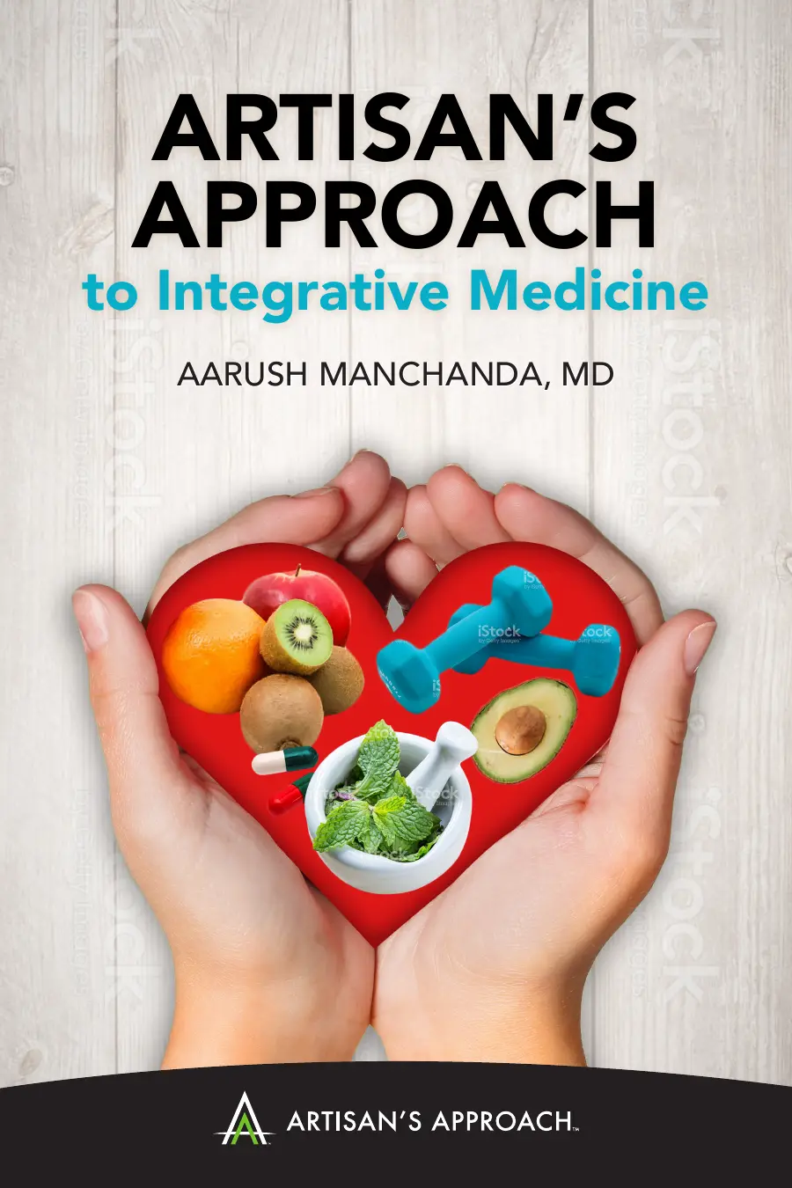
AARUSH MANCHANDA, MD, FACC, FASNC
ARKA IP Reserve • Publishing Collection

EDITORIAL ROADMAP
Book 02 at a glance
A six-part framework for presenting integrative medicine with clarity, clinical responsibility, and respect for individual needs.
PART | EDITORIAL SECTION
I | Introduction
II | Three Types of Illness
III | History of Alternative Medicine
IV | When to Seek Alternative Medicine
V | Types of Alternative Medicine and Treatment
VI | Finding the Balance of Mind and Body
EDITORIAL NOTE
This document is the current working outline for Book 02. Its structure may evolve during writing, medical review, and production.

PART I / BOOK 02
Introduction
A | Why Artisan’s Approach to Integrative Medicine is important
- Include the story of people seeking alternative medicine alone.
- Explore how many people are turning toward alternative medicine.

B | Terminology used to describe integrative, alternative, holistic, and complementary medicine

C | Expense of chronic disease
- How chronic disease affects our overall quality of care.

D | Hospital guidelines
- The 200-page checklist for each ailment.

E | The next step: shared decision-making

PART II / BOOK 02
Three Types of Illness
A | Life- and limb-threatening illness

B | Chronic disease

C | Self-resolving or self-limiting illness

PART III / BOOK 02
History of Alternative
Medicine
This section establishes the historical context and conceptual foundation for the book’s discussion of alternative and integrative medicine.

PART IV / BOOK 02
When to Seek Alternative Medicine
A | Life- and limb-threatening illness
- Only after essential treatment—and during healing.

B | Chronic disease
- Lifestyle changes while seeking treatment.

C | Self-resolving illness
- May arise from an imbalance that can be addressed with alternative medicine based on individual needs and beliefs.

PART V / BOOK 02
Types of Alternative Medicine and Treatment
A | Mind–body approaches
- Massage, art therapy, sports, music, dance medicine, yoga, and meditation.

B | Supplements

C | Herbs
- Including essential oils.

D | Food

PART VI / BOOK 02
Finding the Balance of Mind and Body
This concluding section brings the framework together around a central aim: finding an informed, individualized balance between mind and body.

CURRENT WORKING OUTLINE • BOOK 02 • ARKA IP RESERVE

